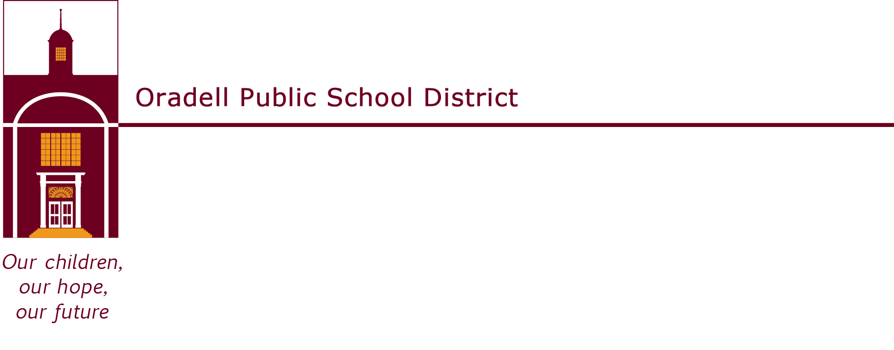
350 Prospect Avenue | Oradell, NJ 07649 | oradellschool.org | (201)261-1180

MEMORANDUM

TO: BOARD MEMBERS
FROM: Megan Bozios and John Marmora
DATE: March 10, 2023
RE: Board Packet – Informational Items

Enclosed, please find the following informational items:
- Tentative Work/Public Session Agenda and Tentative Personnel Committee Report Addendum for Wednesday, March 15, 2023 at 7:30 P.M. in the Auditorium.

Minutes:
- Minutes for Review:
  - February 15, 2023 – Work/Business Session

Finance/Technology:
- Check Register for March 15, 2023 will be sent via e-mail on 3/13/2023 (D2)
- Financial Report for February 2023 (D3)
- Monthly Transfer Report February 2023 (D4)

Committee:
- Committee Meeting Minutes
  - Finance & Technology: March 6, 2023

Please feel free to call Megan Bozios and/or John Marmora before the meeting if you have any questions on agenda items.

