Oradell Public School District

Our children, our hope, our future
POSTING OF VACANCY
School Nurse

Qualifications
1. Valid New Jersey School Nurse Certificate;
2. Demonstrated expertise in school health nursing practice and emergency procedures;
3. Knowledge of child growth and development, community and family dynamics, current health issues and wellness education;
4. Knowledge of community health and social services resources and ability to communicate effectively with other
health professionals and social service agencies;
5. Required criminal history background check and proof of U.S. citizenship or legal resident alien status.

Successful candidates will promote health and safety in the school environment and provide health services to students, faculty and staff and:

• Work in cooperation with the school physician, other school health professionals (e.g. dentist, noncertified nurses, Optometrist), members of the staff, parents and community health professionals to ensure a healthy school climate and to minimize absence and loss of instructional time due to illness;
• Conduct health services and screening programs as required by law and/or board policies and maintain up­
to-date health records on all students;
• Provide emergency and non-emergency care and first-aid in case of injury to students or staff according to established policies and procedures
• Administer prescribed medication to students in accordance with law and board policy.
• Assist teachers with instruction of certain health units and providing information and training on health matters at staff meetings and in-service training while serving as a resource to teachers and administrators on health matters.
• Collaborate with community and other health agencies to meet the health needs of children and families;
• Assist with the preparation of the school's health budget and in the development of policies and procedures for comprehensive health education and services;
• Develop and maintaining the annual School Nursing Plan in conjunction with the Chief School
Administrator, the Director of Special Services and the school physician and
• Prepare health and safety reports as required by law and/or requested by administration.

Please submit letters of interest, resume, copy of School Nurse certification and RN license and any teaching certifications to Scho0lAppl i cations@oradellschool.org.

Salary and work year to be established by the Board of Education through negotiations with the Oradell
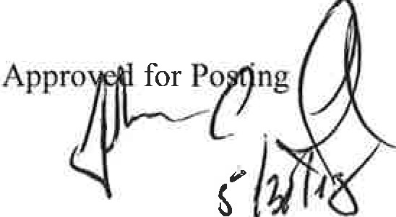Education Association.

Date of Posting: AA/EOE

S/3f/ZO(

