Oradell Public School District

350 Prospect Avenue I Oradell, NJ 07649 I oradellschool.org I (201)261-1180

Our children, our hope, our future

NOTICE OF ANTICIPATED PROFESSIONAL VACANCIES

The following anticipated employment opportunities are expected for the Extended School Year Program, June - August 2019. Interested persons are to apply to schoolapplications@oradellschool.org by May 30, 2019.

Extended School Year Program Opportunities

Speech/Language Specialist(s) to provide direct service, testing and attend Eligibility/IEP Meetings during July and August.

Special Education Teacher(s) to teach ESY classes June 25th- July 19th (No program on the
4th of July). Anticipated positions listed below. All programs will start at 8:30AM. All staff to report at 8:15AM.

ESY Grades 1-2, 3.5 hrs/day ($2,993 total salary)

*Appropriate certification required for all positions.

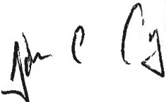
Date of Posting: 5/15/2019

AA/EOE

