**Big Anthony and the Magic Ring Vocabulary**

**gazing**



**drag his feet**

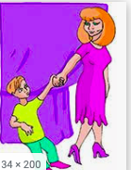

**Startled**

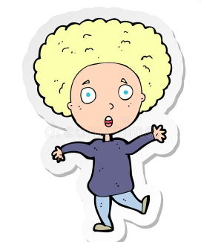

**elegant**



**bloom**



**Character Traits**

