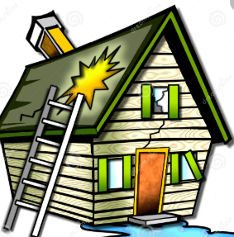 **wrecked your house**

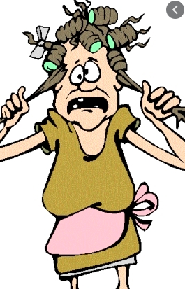 **made you batty**

** crack a window**

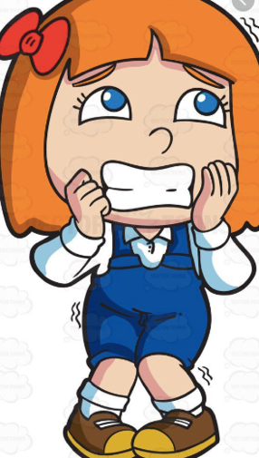 **gives me the creeps**

** leaf to a table**

** to shudder**