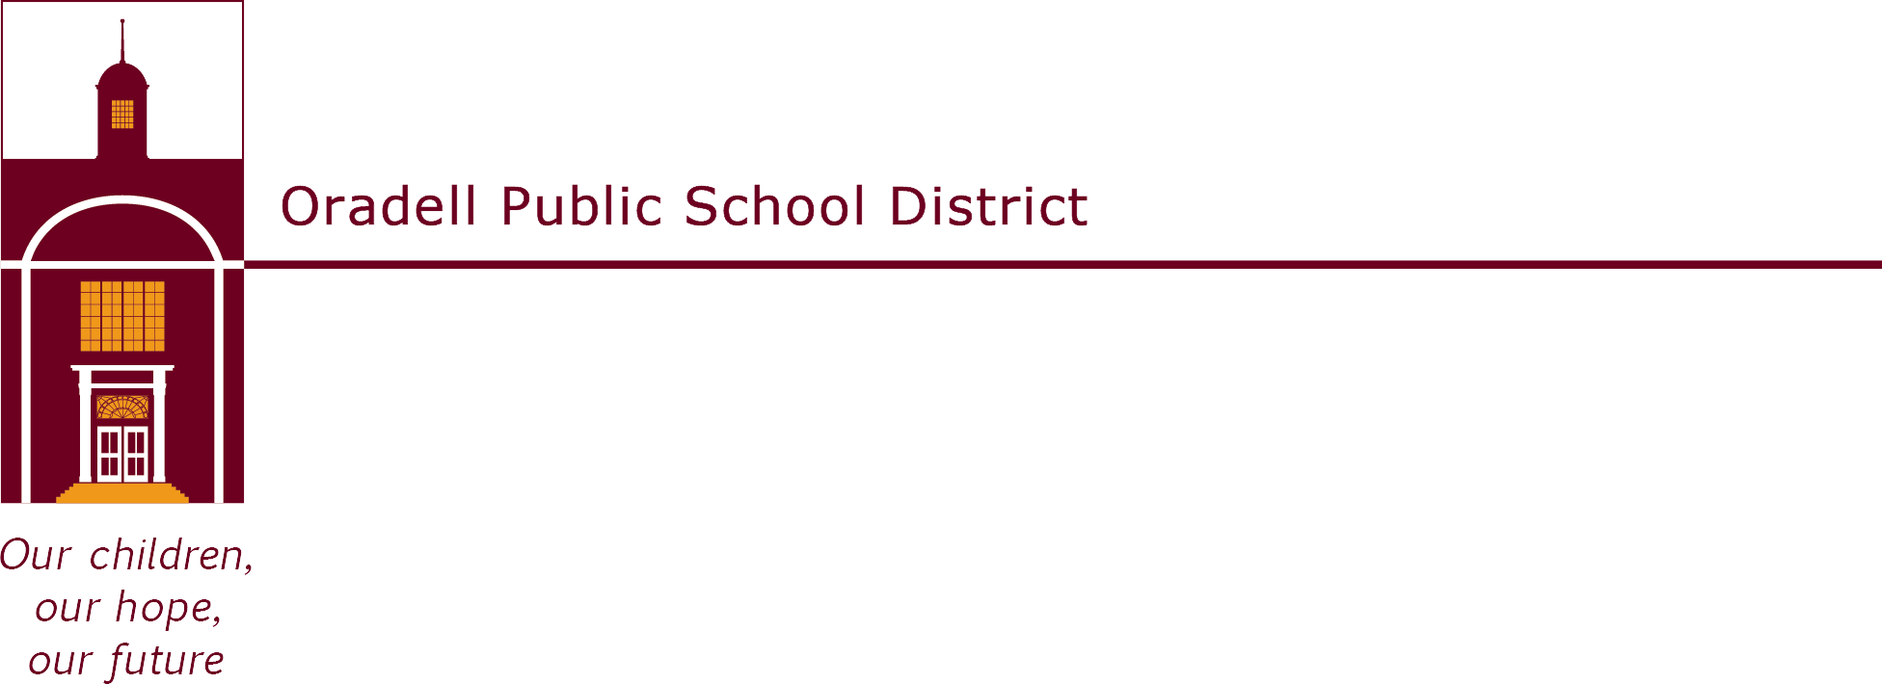

350 Prospect Avenue | Oradell, NJ 07649 | oradellschool.org | (201)261-1180
September 2022
Dear Parents,

Welcome back to another great year in the library! This year fourth graders have the opportunity to participate in a voluntary reading enrichment program called Newbery Scholars. The Newbery Medal is an award given annually to the author of the most distinguished contribution to American literature for children. Students will be reading books chosen from a selected list of Newbery Award winner and Honor books. They must then successfully complete a short quiz about the book on their computer in the OPS Library.

For every 10 points earned, students will receive a Newbery badge. Each book is worth a different number of points. In order to become a fourth grade Newbery Scholar, the student must earn 50 points. All Newbery Scholars will receive certificates of achievement and their names will be added to the Newbery plaque, which is on display outside of the library. The students who become Newbery Scholars in fourth, fifth, and sixth grade will receive an award in June of their graduation year.

The Newbery Scholars Program is intended to introduce students to a wide variety of children’s literature and to develop literature skills and understanding. Although participation in the program is voluntary, I hope that you will encourage your child to take part. In order to reach 50 points, students are encouraged to work steadily over the school year, rather than try to catch up with points during the last month of school. The program will begin on Thursday, September 22, 2022 and will tentatively end on Friday, June 9, 2023.

A list of Newbery Award and Honor books that are included in this year’s program can be found on the OPS library website. The books are available in the school library and the Oradell Public Library.

If you have any questions, please feel free to contact me. Happy Reading!

Lisa Santangelo
Library Clerk
Oradell Public School
(201) 261-1180 ext. 1012
santangelol@oradellschool.org

