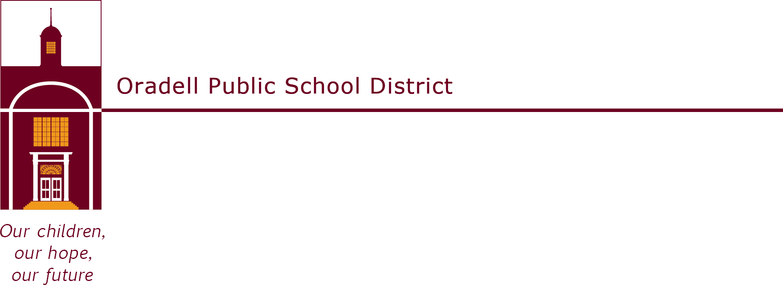

350 Prospect Avenue | Oradell, NJ 07649 | oradellschool.org | (201)261-1180

September 2022

Dear Parents,

Welcome back to another great year in the library! Third grade students have the opportunity to participate in the Bookworm Program, a voluntary reading enrichment program that is intended to introduce third graders to a wide variety of fine children’s literature. With the guidance of their teacher and the media specialist, students will choose a book from a list that has been selected for the program. The third grade book list can be found on the OPS library website.

The Bookworm Program will run until June and the names of those students who have earned 70 points over the course of the year will be inscribed on a plaque that is displayed outside the library. Students earn points when they pass a quiz for a book. Each book is worth a different number of points, as indicated on the book list. Students are encouraged to keep reading by earning prizes at various point levels. Students may take a quiz after school or during the day at designated times in the school library (i.e. snack, DEAR time.)

The reading level of the books ranges from first to fourth grade, so students at all reading levels can participate comfortably in the program. Although participation in the program is voluntary, I hope that you will encourage your child to take part. Children must take the quiz in school, but they may enjoy reading and discussing their books with you at home.

Several copies of each of the books are available in the school library. Most of the books can also be found at the Oradell Public Library. Students who intend to reach 70 points should be encouraged to work steadily over the school year, rather than try to catch up during the last few weeks of the program.
The program will begin on Thursday, September 22, 2022 and will tentatively end on
Friday, June 9, 2023.

If you have any questions, please feel free to contact me. Happy Reading!

Lisa Santangelo
Library Clerk
Oradell Public School
(201) 261-1180 ext. 1012
santangelol@oradellschool.org

