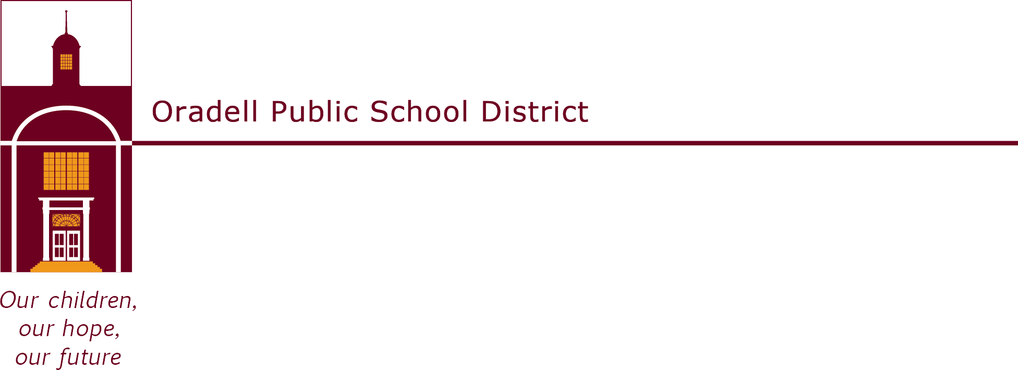

350 Prospect Avenue | Oradell, NJ 07649 | oradellschool.org | (201)261-1180
September 2021
Dear Parents,

Welcome back to another great year in the library! We are excited to begin the second grade Reading Stars program, which is a reading enrichment program that encourages students to read for pleasure. Each child will have the chance to contribute stars that will decorate the walls of the Media Center. In order to earn stars, students must spend time reading or being read to at home. The children will be awarded a variety of stars and certificates as they read over the year. The first star is earned after one hour spent reading. A special award will be given to every child who reads for a total of 100 hours during the year.
Students should keep track of their reading log, which must be signed by a parent or guardian and returned to the Media Center when each sheet has been completed. Time spent reading in school should not be included in the log. A sample reading log is attached and more are available for the children to pick up in the library.
We hope that you will encourage your child to participate in this program. Many teachers require reading for homework, so why not record that reading and earn stars for the library at the same time? The teachers and the media specialist will be suggesting good books for the children to take home and read. The program will begin on Monday, September 27, 2021 and will tentatively end on
Friday, June 10, 2022. We are excited to have the library filled with reading stars by the end of the year!
If you have any questions, please feel free to contact me.

Happy Reading!

Lisa Santangelo
Library Clerk
Oradell Public School
(201) 261-1180 ext. 1012
santangelol@oradellschool.org

