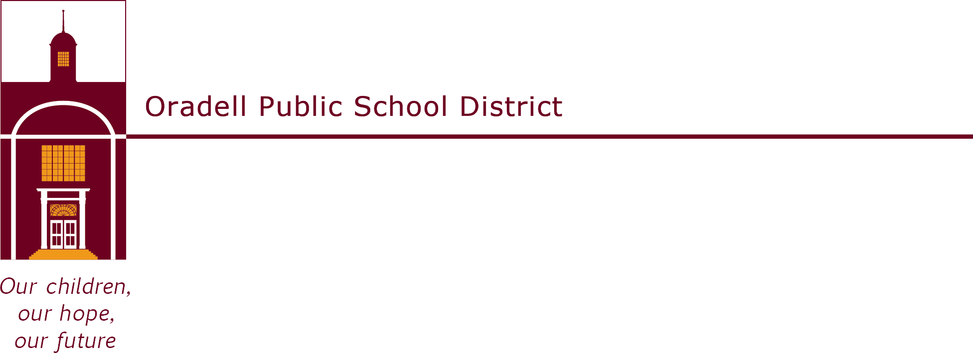

350 Prospect Avenue | Oradell, NJ 07649 | oradellschool.org | (201)261-1180

September 2021

Dear Parents,

Welcome back to another great year in the library! We are excited to tell you about our reading program for first grade students. First grade students have the opportunity to participate in the Caldecott Club, which is a reading enrichment program that is based on Caldecott award winning books. The Caldecott Medal is awarded annually to the artist of the most distinguished American picture book for children. In addition to gold medal books, we also include the Caldecott Honor books in the program. All the books have been placed on a special shelf in the school library.

Each child will have a chance to contribute gold stars to the Caldecott Club. In order to earn stars, students must select a Caldecott book and read it or have it read to them. The children will then illustrate their favorite part of the story, using any medium they choose – crayons, markers, collage, etc. The artwork should have a caption with the title of the book and the child’s name. The attached form should be filled out and returned to the library with the artwork. Additional forms are available in the library. For each book and piece of artwork completed, students will add a star to the Caldecott Club display in the library. Students will receive a button for the first piece of artwork completed and will receive certificates for every fifth book after that.

The program’s goal is to introduce first graders to a wide variety of children’s literature and the wonderful art of children’s picture books. They will be reading many Caldecott books in the library, so students may create their artwork at home based on a book read in school as well. The program will begin on Monday, September 27, 2021 and will tentatively end on Friday, June 10, 2022. We hope you will read and participate in this program with your child!

If you have any questions or comments, please feel free to contact me. Happy Reading!

Lisa Santangelo
Library Clerk
Oradell Public School
(201) 261-1180 ext. 1012
santangelol@oradellschool.org

