6th Grade Walkathon
June 14th at 3:00
to support the Center for Food Action
Weekend Snack Pack Program
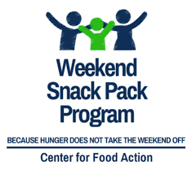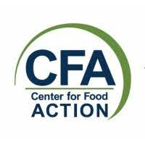

Please support our 6th graders as they participate in a walkathon on June 14th at 3:00 to raise money for the Weekend Snack Pack Program, part of the Center for Food Action. This program provides healthy, kid friendly food to students who receive free or reduced lunch during the school week to ensure they receive necessary nutrition over the weekend. Our 6th graders will stand outside at dismissal with information about the program as well as collection bins. Please contribute whatever cash donations you can - no amount is too small!

This is not an OPS school sponsored event. This activity is sponsored by the
6th Grade Give Back Committee

