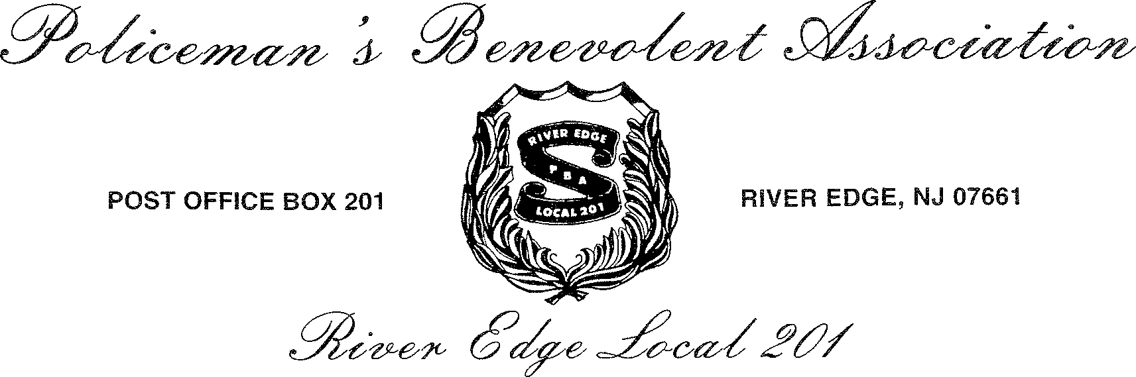

RIVER EDGE PBA LOCAL 201 SUMMER KICKOFF
POOL PARTY!

Friday, June 7th 5pm-9pm

At the River Edge Swim Club
600 Riverside Way, River Edge, NJ 07661

Please return this form to the River Edge Police Department located at 705 Kinderkamack Rd. River Edge, NJ. Please use an envelope marked with your family’s name on it and Attn: River Edge PBA 201. Please return by Friday, May 31, 2019. Make check payable to PBA Local 201.
Please Print:

*Parents Name:

*Emergency Phone #
*E-mail

Number of participants @ $20 each. Adults supervising and eating @ $10 each.
** Please be advised that an adult must accompany children under 10 years old. There is no fee required if parents are just going to supervise their children.
Supervision fee applies only if you plan to eat.
**Please sign the Insurance form on the back of this page.

Total amount enclosed $ . Full name of participants and age:
1 age 2 age

3 age 4 age

*Please see other side for Insurance waiver →→→→→→→

PLEASE READ AND SIGN BELOW – SIGNATURE REQUIRED

RELEASE OF LIABILITY
I, (herein “Participant”), hereby acknowledge and agree to the following, as a condition of participation in the River Edge PBA Local 201 Summer Kick Off.

- My involvement and/or participation in the River Edge PBA Local 201 Summer Kick Off is voluntary and I am acting under my own free will.

- There is a risk of danger, bodily harm, injury, emotional stress, or death as a result of my participation.

- There is the potential for risks and dangers that may not be obvious or reasonably foreseeable at this time.

- I do not have any medical ailments, physical limitations, or mental disabilities that will prevent my participation in the River Edge PBA Local 201 Summer Kick Off, with or without reasonable accommodations.

- The River Edge PBA, The Borough of River Edge and the River Edge Swim Club Inc. undertakes no direct legal or financial responsibility for my personal safety or well being when I am participating in the River Edge PBA Local 201 Summer Kick Off.

- I assume the risks, including, but not limited to, those outlined in Section 3 of this agreement.

- I forever waive, release, absolve and indemnify and agree to hold harmless the River Edge PBA Local 201, The Borough of River Edge and the River Edge Swim Club Inc. including but not limited to employees, organizers, sponsors, officers, supervisors, participants, agents, volunteers, elected officials, lifeguards, staff members from any and all claims and causes of action including attorney fees and defense costs that I or my representatives now have or may have in the future for personal injury, property damage or wrongful death occurring to me, arising out of an injury to myself or others whether the result of negligence or for any other cause in the participation of the River Edge PBA Local 201 Summer Kick Off.

- I am 100% liable for all medical expenses incurred as a result of any injury or property damage during my participation in River Edge PBA Local 201 Summer Kick Off.

- I am responsible for myself and any guest under my care for the entire event at all times.

- In the event that any one or more of the provisions of this agreement shall be held to be invalid, illegal, unenforceable or in conflict with the law according to the jurisdiction of the State of New Jersey, the remaining portions will not be invalidated, and shall remain in full force and effect.

- This is a legally binding contract, but it is not meant to pronounce any claims or defenses that are legally prohibited.

- I will allow pictures of my child to be taken for future Pool Party promotional material.

I attest that I have read and understand this document, and agree to all the provisions listed above.

___________________________________ ___________________ Participants/Guardian Signature Date

___________________________________ Participants/Guardian Name (Please Print)

