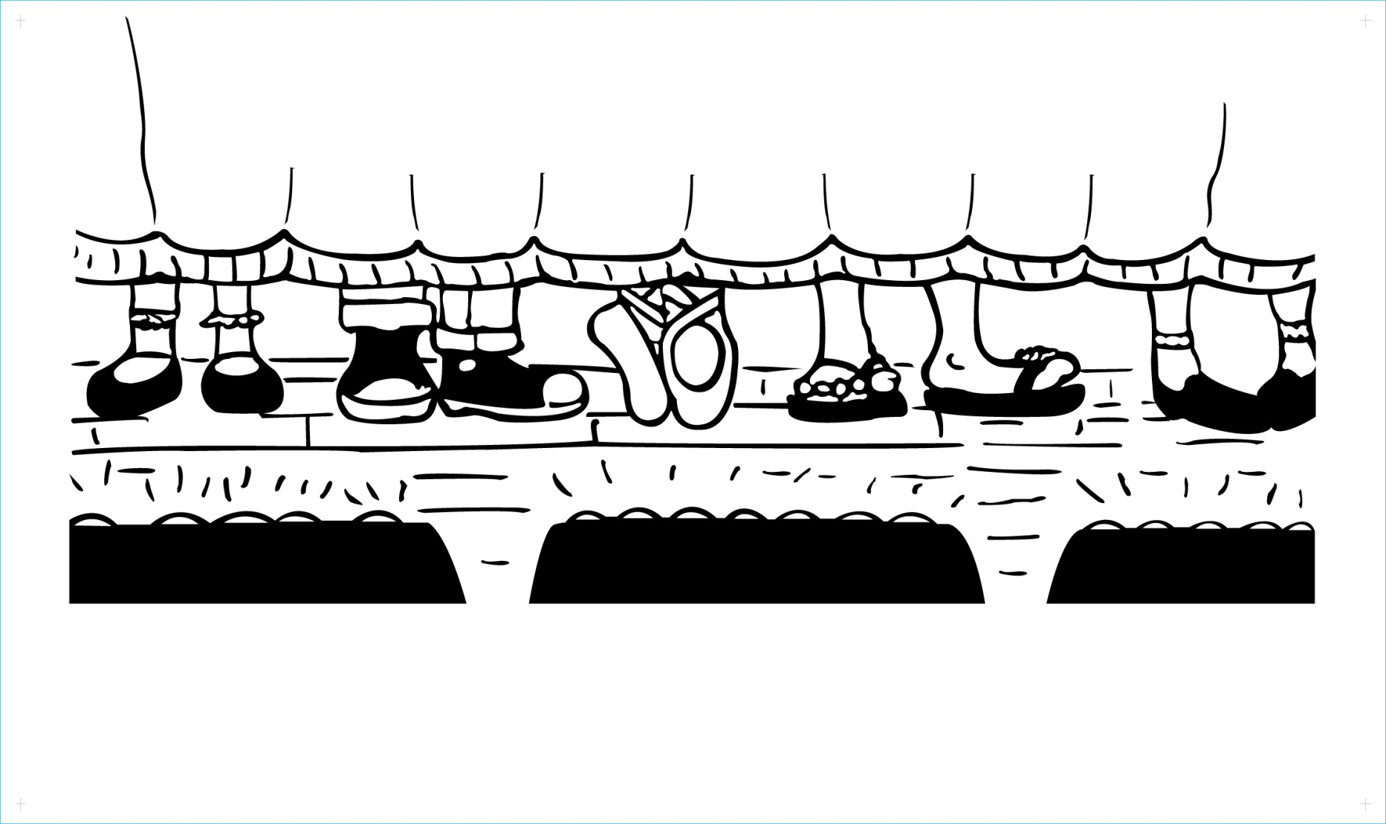

**All The World's A Stage**

**Winter Theatre Program**

***with Nikki Hendricks & Chris Schlegel***

***Improvisation & Movement for Actors Class***

**10-session class on the following Mondays:**

1/8, 1/22, 1/29, 2/5, 2/12, 2/26, 3/5, 3/12, 3/19, 3/26

**Classes – 4:00pm – 5:15pm**

**First Congregational Church**

109 Continental Avenue, River Edge, NJ

**Explore various improv techniques and movement exercises.**

**Increase your confidence and build your acting skills**

**in our interactive, fun class!**

Contact us if you are interested in reserving your place.

(201) 468-1292

atwas300@gmail.com

www.facebook.com/ATWASRiverEdge

*The contents of this flyer are provided solely as a public service. The event or activity described here is not in any way affiliated with the Oradell Public School, nor is it endorsed by the Oradell Board of Education.*