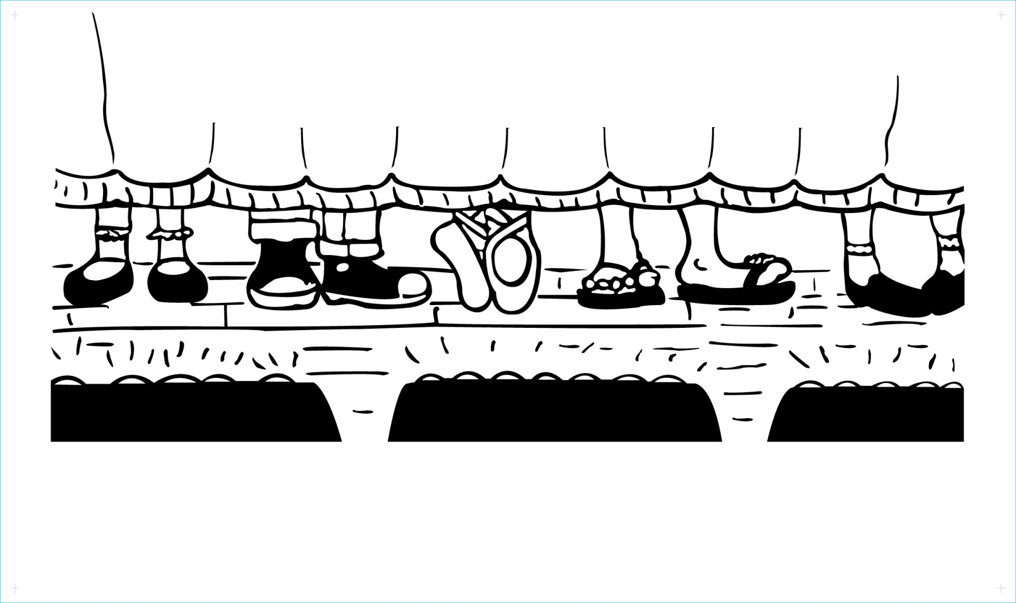

**All The World's A Stage**

**Summer Theatre Program**

Directors

Carol Richardi - Nikki Hendricks - Chris Schlegel

***Celebrating our 10th Anniversary!***

**June 25 - July 27, 2018**

**8:45am - 12:45pm**

**Campers**

Ages 7 to 14

**Junior Counselors**

Ages 15 -16

For information: (201) 468-1292

atwas300@gmail.com

www.facebook.com/ATWASRiverEdge

Location: First Congregational Church of River Edge

Our mission is to provide children with a quality experience in the performing arts. It is our hope that during this process children will increase their self-confidence, develop stage presence, learn to work together and respect each other as a team, while building their acting, singing and dancing skills.

The contents of this flyer are provided solely as a public service. The event or activity described here is not in any way affiliated with the Oradell Public School, nor is it endorsed by the Oradell Board of Education.