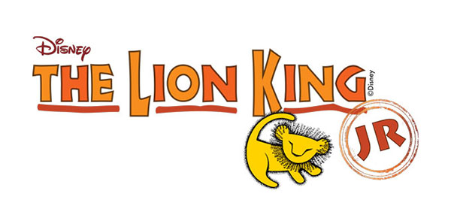
Order a Lion King Jr. T-shirt today!
This year’s 5th and 6th Spring Musical is Lion King Jr. We would like to offer to the school community as well as our talented cast members an opportunity to purchase a limited-edition souvenir T-shirt. T-shirts are of high quality cotton with the Lion King Jr. logo printed on the front. Students performing in the show can also have “CAST MEMBER” printed on the back. The T-shirts will be red with an orange and gold logo and are $12 each.

Size | Quantity | Total $ ($12 each)
Child Medium, with “CAST MEMBER”
Child Large, with “CAST MEMBER”
Adult Small, with “CAST MEMBER”
Adult Medium, with “CAST MEMBER”
Adult Large, with “CAST MEMBER”
Child Medium with logo only
Child Large with logo only
Adult Small with logo only
Adult Medium with logo only
Adult Large with logo only
TOTAL

Please make checks payable to: Oradell Board of Education
Hand in your check with this form to: Ms. Richardi
Note on envelope: LION KING JR T-SHIRT

Child’s Name _________________________________________________________________________
Grade/Teacher_______________________________________________________________________
- T-Shirts MUST be ordered in advance; DEADLINE is WEDNESDAY, APRIL 11th
- Any questions – please contact Dorothy Ricciardi at (201) 961-4428 or dottier11@gmail.com
- T-Shirts will be delivered to your child’s classroom well before the show!
SHOW YOUR SUPPORT FOR OUR SCHOOL MUSIC PROGRAM BY WEARING YOUR T-SHIRTS TO THE DRESS REHEARSAL! THERE WILL ALSO BE A PHOTO TAKEN OF ALL CAST MEMBERS IN THE T-SHIRTS.

