6th Grade Give Back Fundraiser

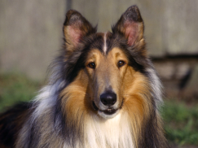
As part of the 6th Grade Activities, a special Give Back Committee has been formed. The students will be participating in 3 projects to help serve the community. One of these projects is a Dollar Donation Pledge to collect money for a specific charity. The 6th grade students were given the opportunity to vote for one of 4 choices and this year they chose Grateful Doggies as the recipient of the Dollar Donation Pledge.
Grateful Doggies mission is to safely transport as many dogs as possible in a safe and comfortable manner from undesirable lives to forever homes.
During the 2 weeks beginning March 7nd through March 18th, the 6th graders will be collecting donations for this very worthy cause. If you would like to help, please send in your donation in an envelope addressed to the 6th Grade Activities – Dollar Donation Pledge, with your child’s name and class on the front. Checks should be made payable to Grateful Doggies.
We are attaching a Donation Pledge sheet that your child can decorate, fill out and return with their donation, which will be hung in the front hallway of the school showing each OPS student’s support for the 6th grade charity!
Your generosity is greatly appreciated!

The GiveBack Committee

