Oradell Art Show 2016
THE COMMUNITY FENCE
WEDNESDAY, MAY 25th 6:30-8:00 PM
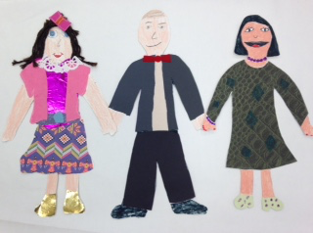

ALL artists PRE-K to 6TH grade

New
CLAUDE MONET’S JAPANESE BRIDGE
JAPANESE CHERRY BLOSSOMS
BACKPACKS CONTOUR LINE DRAWINGS
SURPRISE GUEST ARTISTS

Fan Favorites

- FAMILY PORTRAIT PILLOWS
- VINCENT van GOGH & GEORGES SEURAT FLOWERS
- EGYPTIAN PROFILES
- GEORGIA O’KEEFFE WATERCOLOR FLOWERS
- WOVEN FABRIC, COIL POTTERY

