Candy Grams
Candy Grams will be delivered after the first night of the show!
Reward your star…with a candy bar!

Is your child or friend in Shrek Jr.? You can send them a candy gram to reward them for all their hard work.

Ordering a candy gram is so easy!

First, write a note to that special child. You will need to print and write a message for each candy gram you send. The star will be delivered to the recipient along with the type of candy you order. (See list on 2nd page for a list of candy and the order form)

CANDY ORDER LIST
Next, select your favorite candy! Remember you will need a star and candy order for each child.
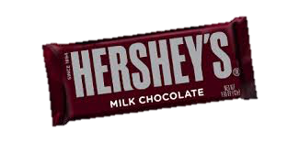
_____ Hershey Bar
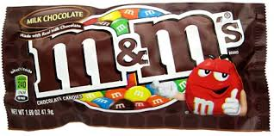
_____ Plain M&Ms
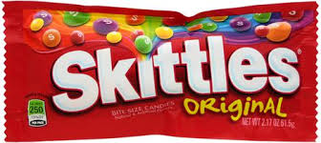
_____ Skittles
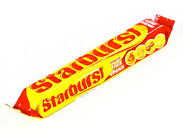
_____ Starbursts
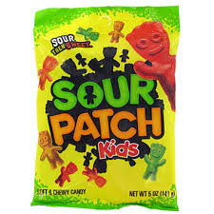
_____ Sour Patch Kids
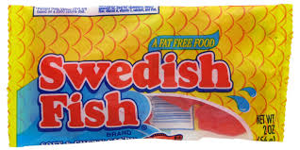
_____ Swedish Fish
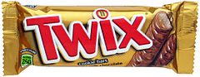
_____ Twix
Don’t forget to send it and pay!
Each Candy Gram Costs $2.00

Child’s Name: ______________________ Grade/Class:________________

Number of candy grams __________________ X $2.00 = ___________

Please pay in cash or write a check to the Oradell Board of Education. Send the order in an envelope marked Student Government. Your child will receive this on Friday morning after the first showing.
Orders due by March 9th.

