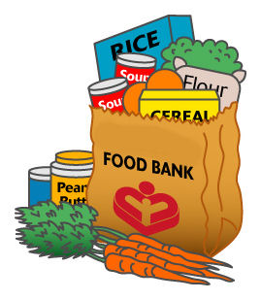 6th Grade Give Back
Food & Personal Items Drive

6th Graders are invited to help LOCAL FAMILIES by participating in a
Food & Personal Items Drive to benefit St. Andrew's Food Pantry, Westwood

Activities:
- Donate: April 13th – 27th
- Package Personal Items: April 29th
- Distribute to Families in Need: April 30th

6th Grade Students & Families are asked to donate the following:

Teacher | Food  (*Plastic containers if possible) | Personal Items  (**Individually wrapped or multi-pack)
Albrecht | 2 Cans Fruit (Pears, Peaches, Pineapple) | 2 Bottles of Shampoo
Duthie | 1 Jar Jelly & 1 Jar Peanut Butter* | 2 Bars Soap**
Kasturas | 1 Jar Jelly & 1 Jar Peanut Butter* | 2 Tubes of Toothpaste
McGill | 1 Box Pancake Mix & 1 Syrup | 2 Toothbrushes**
Min | 2 Packages Knorr or Lipton Pasta Sides | 2 Deodorant
Additional items are welcomed!
Donations should be dropped off in your classroom April 13 – 27

--------------------- Fill out info below & return to your teacher ---------------------

6th Grade Students Can Also Donate their Time. Please check if you’d like to help:
______ Package personal items @ OPS – Wednesday, April 29th , 2:30-3:30 pm

______ Distribute @ St. Andrew's in Westwood – Thursday, April 30th, 7:00-8:30 pm
Carpools to be arranged

________________ ____________ ___________________ ______________
Student Name Teacher Name Parent Email Parent Signature

Please return this form to your teacher by April 24, 2015.
For questions, please contact Bobbie Menzel: barbarasmenzel@gmail.com

