Join Girl Scouts!
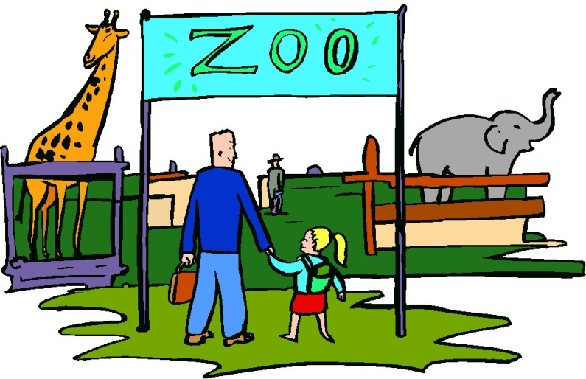
All girls in grades 1st-3rd grade are invited to join us for a fun filled day at Van Saun Park Zoo
When: Thursday April 17th, 2014
Time: Beginning at 10:30 a.m. – 1:00 p.m.
What’s Included: 2 classes with up close look at real live animals while learning about their habitats and lives, an animal story, an animal craft, train ride, admission and zoo tour for the girl and Girl Scout cookie snack!
Cost: $33 per girl (registration for 2013-14 year + program)
Deadline for all registrations is April 8th

To RSVP for this event or for more information contact
Christina Crismale: 201-967-8100 ext 232/ CCrismale@gsnnj.org
Registration is required- Bring Form and Money day of event

