Oradell/Emerson Rotary Club announces….

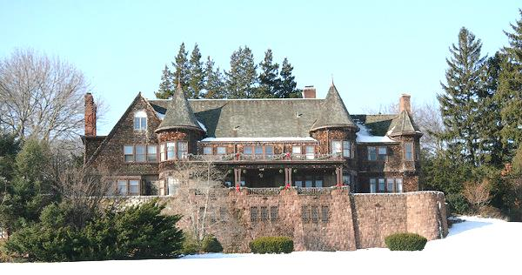

“KIDS CHRISTMAS NJ”
spreading Christmas joy…one child at a time

Saturday December 28, 2013
At the Historic Blauvelt Mansion, Oradell, NJ
7:30-12 midnight
light fare *merry music*holiday dress

Ticket/Checks for $65 each can be sent to: KCNJ: PO Box 35, Oradell NJ

Money raised benefits: Oradell/Emerson Rotary Club
Kids Christmas NJ
The Candle Lighters
MakeAChangeDiaperBank

Please bring a package of baby diapers to be donated to MakeAChangeDiaperBank.

Questions? Or interested in helping? Please email Tom Kelly at:Thomas.kelly@morganstanley.com.

*Founded in 1996, “KIDS CHRISTMAS NYC” raised thousands of dollars and delivered hundreds of books to inner city children at Christmas time. In 2009,”KIDS CHRISTMAS” moved to New Jersey furthering its mission of helping those less fortunate. In 2013,”KIDS CHRISTMAS NJ” expanded to Pennsylavania. KIDS CHRISTMAS NJ is a registered 501c(3) tax exempt organization.

“KIDS CHRISTMAS NJ”
spreading Christmas joy…one child at a time

